Alphanumeric LCD

Liquid Crystal Display also called as LCD is very helpful in providing user interface as well as for debugging purpose. The most commonly used Character based LCDs are based on Hitachi's HD44780 controller or other which are compatible with HD44580. The most commonly used LCDs found in the market today are 1 Line, 2 Line or 4 Line LCDs which have only 1 controller and support at most of 80 characters, whereas LCDs supporting more than 80 characters make use of 2 HD44780 controllers.
Pin Description
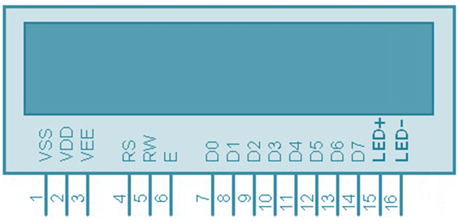

Pin No. | Name | Description
1 | VSS | Power supply (GND)
2 | VCC | Power supply (+5V)
3 | VEE | Contrast adjust
4 | RS | 0 = Instruction input  1 = Data input
5 | R/W | 0 = Write to LCD module  1 = Read from LCD module
6 | EN | Enable signal
7 | D0 | Data bus line 0 (LSB)
8 | D1 | Data bus line 1
9 | D2 | Data bus line 2
10 | D3 | Data bus line 3
11 | D4 | Data bus line 4
12 | D5 | Data bus line 5
13 | D6 | Data bus line 6
14 | D7 | Data bus line 7 (MSB)
15 | LED+ | Back Light VCC
16 | LED- | Back Light GND

DDRAM - Display Data RAM:

Display data RAM (DDRAM) stores display data represented in 8-bit character codes. Its extended capacity is 80 X 8 bits, or 80 characters. The area in display data RAM (DDRAM) that is not used for display can be used as general data RAM. So whatever you send on the DDRAM is actually displayed on the LCD. For LCDs like 1x16, only 16 characters are visible, so whatever you write after 16 chars is written in DDRAM but is not visible to the user.
CGROM - Character Generator ROM:

Now you might be thinking that when you send an ASCII value to DDRAM, how the character is displayed on LCD? So the answer is CGROM. The character generator ROM generates 5 x 8 dot or 5 x 10 dot character patterns from 8-bit character codes. It can generate 208 5 x 8 dot character patterns and 32 5 x 10 dot character patterns.
CGRAM - Character Generator RAM:

As clear from the name, CGRAM area is used to create custom characters in LCD. In the character generator RAM, the user can rewrite character patterns by program. For 5 x 8 dots, eight character patterns can be written, and for 5 x 10 dots, four character patterns can be written.
BF - Busy Flag:
Busy Flag is a status indicator flag for LCD. When we send a command or data to the LCD for processing, this flag is set (i.e. BF =1) and as soon as the instruction is executed successfully this flag is cleared (BF = 0). This is helpful in producing and exact amount of delay for the LCD processing.
To read Busy Flag, the condition RS = 0 and R/W = 1 must be met and The MSB of the LCD data bus (D7) act as busy flag. When BF = 1 means LCD is busy and will not accept next command or data and BF = 0 means LCD is ready for the next command or data to process.
Instruction Register (IR) and Data Register (DR):
There are two 8-bit registers in HD44780 controller Instruction and Data register. Instruction register corresponds to the register where you send commands to LCD e.g. LCD shift command, LCD clear, LCD address etc. and Data register is used for storing data which is to be displayed on LCD. When send the enable signal of the LCD is asserted, the data on the pins is latched in to the data register and data is then moved automatically to the DDRAM and hence is displayed on the LCD. Data Register is not only used for sending data to DDRAM but also for CGRAM, the address where you want to send the data, is decided by the instruction you send to LCD.
Commands and Instruction set:

Only the instruction register (IR) and the data register (DR) of the LCD can be controlled by the MCU. Before starting the internal operation of the LCD, control information is temporarily stored into these registers to allow interfacing with various MCUs, which operate at different speeds, or various peripheral control devices. The internal operation of the LCD is determined by signals sent from the MCU. These signals, which include register selection signal (RS), read/write signal (R/W), and the data bus (DB0 to DB7), make up the LCD instructions (Table 3). There are four categories of instructions that:

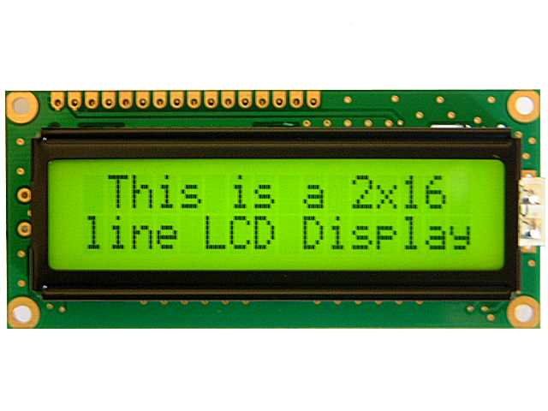

Introduction:

As a low power alternative to LEDs and 7-segment LED-displays, small Liquid Crystal Displays (LCD) with only a limited number of segments are becoming more and more popular. Due to complex driving waveforms, interfacing to LCDs has traditionally been done via a hardware driver either integrated in the LCD or MCU. But as the complexity of the waveform is dependent on the number of back planes in the LCD, these small LCDs with few common lines are less complex and software interfaces can be suitable. This application note describes software driving of LCDs with one common line, using the static driving method.
An AVR driving a LCD display directly, using general IO:
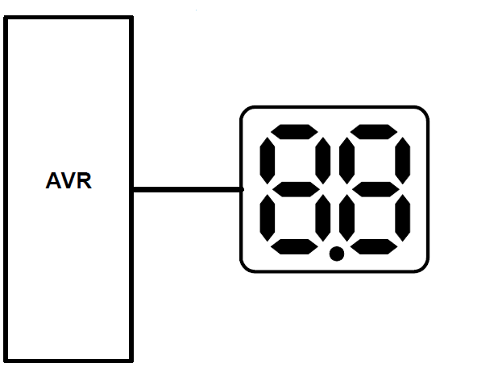

Theory of operation:

This section provides an overview of common features and a introduction to terminology used in relation to LCD glass. Theory will focus upon driving of LCD glass with one common line. This section describes the terminology used throughout this document. One of the bars/dots in a LCD display, controlled individually. A frame is equivalent to one period of the cyclic waveform that is written to a Frame rate is the number of frames per second. The frame rate should normally be kept high enough to avoid that the human eye perceives the segments as flickering and low enough to avoid ghosting. Ghosting occurs when segments are energized due to cross talk between segment lines. The frame rate should normally be kept between 30 and 100 Hz. Electrical connection terminal shared by all display segments. Electrical connection terminal connected to a single segment. The LCD is based upon a display technology that uses rod-shaped molecules (liquid crystals) that flow like liquid and bend light. Non-energized, the crystals direct light through two polarization filters, allowing a natural background color to show, making it invisible. When energized, they redirect the light to be absorbed in one of the polarizers, causing the dark appearance making it visible. The smallest viewing element that can be turned visible/invisible (energized/non-energized) is referred to as a display segment. Each display segment has two connection terminals. One terminal is connected to a segment driver and the other to a common terminal. One common terminal is shared by a number of segments. Applying a voltage between the common terminal and a segment terminal energizes the segment. Additionally the segment voltage has to be alternated. DC (direct current) will cause electrophoresis effects in the liquid crystal and will degrade the display. Consequently the voltages on both the common terminal and the segment terminals must alter. There are basically two driving methods for displays: Static and multiplexed. In the multiplexed driving method many displays share segment lines, and the controlling of several common lines multiplexes the displays. This method will need a variety of complex waveforms and multiple analog levels to be sent to the display. In the static driving method only one common line is used and each display segment will have their unique terminal. This method will need relatively simple waveforms applied to terminals. However, the static driving method is not suitable for LCDs with many segments since each segment will need one dedicated output-pin from the MCU. For more LCD theory please refer to application note AVR065: LCD Driver for the STK502 and AVR Butterfly. This application note will use the static driving method.

WHAT ARE THE BASIC
COMPONENTS IN AN LCD PANEL:

An LCD panel, or more commonly known as a piece of “glass”, is constructed of many layers. Figure 1 shows all the layers that are typically present in LCD panels. The first layer is called the front polarizer.

BASIC LCD COMPONENTS:

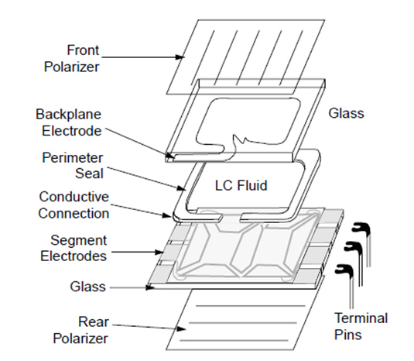

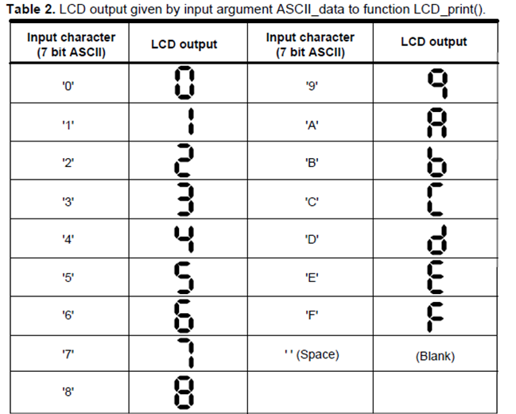

Features:

• Software driver for displays with one common line
• Suitable for parts without on-chip hardware for LCD driving
• Control up to 15 segments using 16 IO lines
• Fully interrupt driven operation

- Designate LCD functions, such as display format, data length, etc.
- Set internal RAM addresses
- Perform data transfer with internal RAM
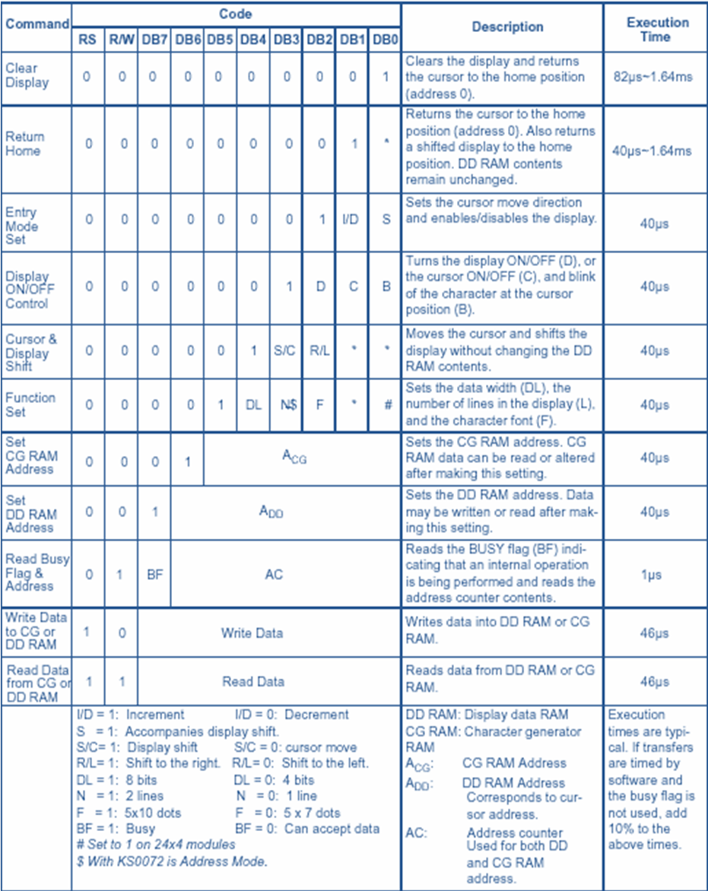
- Perform miscellaneous functions
Although looking at the table you can make your own commands and test them. Below is a brief list of useful commands which are used frequently while working on the LCD.

No. | Instruction | Hex | Decimal
1 | Function Set: 8-bit, 1 Line, 5x7 Dots | 0x30 | 48
2 | Function Set: 8-bit, 2 Line, 5x7 Dots | 0x38 | 56
3 | Function Set: 4-bit, 1 Line, 5x7 Dots | 0x20 | 32
4 | Function Set: 4-bit, 2 Line, 5x7 Dots | 0x28 | 40
5 | Entry Mode | 0x06 | 6
6 | Display off Cursor off  (clearing display without clearing DDRAM content) | 0x08 | 8
7 | Display on Cursor on | 0x0E | 14
8 | Display on Cursor off | 0x0C | 12
9 | Display on Cursor blinking | 0x0F | 15
10 | Shift entire display left | 0x18 | 24
12 | Shift entire display right | 0x1C | 30
13 | Move cursor left by one character | 0x10 | 16
14 | Move cursor right by one character | 0x14 | 20
15 | Clear Display (also clear DDRAM content) | 0x01 | 1
16 | Set DDRAM address or cursor position on display | 0x80+add | 128+add
17 | Set CGRAM address or set pointer to CGRAM location | 0x40+add | 64+add
Sending Commands to LCD
To send commands we simply need to select the command register. Everything is same as we have done in the initialization routine. But we will summarize the common steps and put them in a single subroutine. Following are the steps:
- move data to LCD port
- select command register
- select write operation
- send enable signal
- wait for LCD to process the command
Sending Data to LCD
To send data we simply need to select the data register. Everything is same as the command routine. Following are the steps:
- move data to LCD port
- select data register
- select write operation
- send enable signal
- wait for LCD to process the data

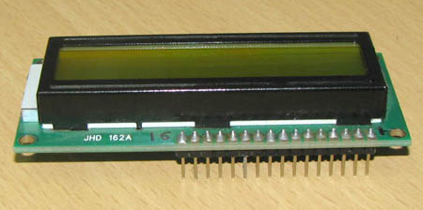

LCD (Liquid Crystal Display) screen is an electronic display module and find a wide range of applications. A 16x2 LCD display is very basic module and is very commonly used in various devices and circuits. These modules are preferred over seven segments and other multi segment LEDs. The reasons being: LCDs are economical; easily programmable; have no limitation of displaying special & even custom characters (unlike in seven segments), animations and so on.
A 16x2 LCD means it can display 16 characters per line and there are 2 such lines. In this LCD each character is displayed in 5x7 pixel matrix. This LCD has two registers, namely, Command and Data.

The command register stores the command instructions given to the LCD. A command is an instruction given to LCD to do a predefined task like initializing it, clearing its screen, setting the cursor position, controlling display etc. The data register stores the data to be displayed on the LCD. The data is the ASCII value of the character to be displayed on the LCD.

Pin Diagram:

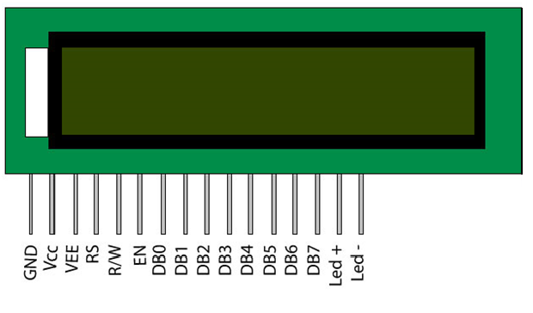

Pin Description:

Pin No | Function | Name
1 | Ground (0V) | Ground
2 | Supply voltage; 5V (4.7V – 5.3V) | Vcc
3 | Contrast adjustment; through a variable | V_{EE}
4 | Selects command register when low; and data register when high | Register Select
5 | Low to write to the register; High to read from the register | Read/write
6 | Sends data to data pins when a high to low pulse is given | Enable
7 | 8-bit data pins | DB0
8 | 8-bit data pins | DB1
9 | 8-bit data pins | DB2
10 | 8-bit data pins | DB3
11 | 8-bit data pins | DB4
12 | 8-bit data pins | DB5
13 | 8-bit data pins | DB6
14 | 8-bit data pins | DB7
15 | Backlight V_{CC} (5V) | Led+
16 | Backlight Ground (0V) | Led-

